PART 1

1. 20% of websites do not respond to pings at all. 34% of websites have at least one failed ping.

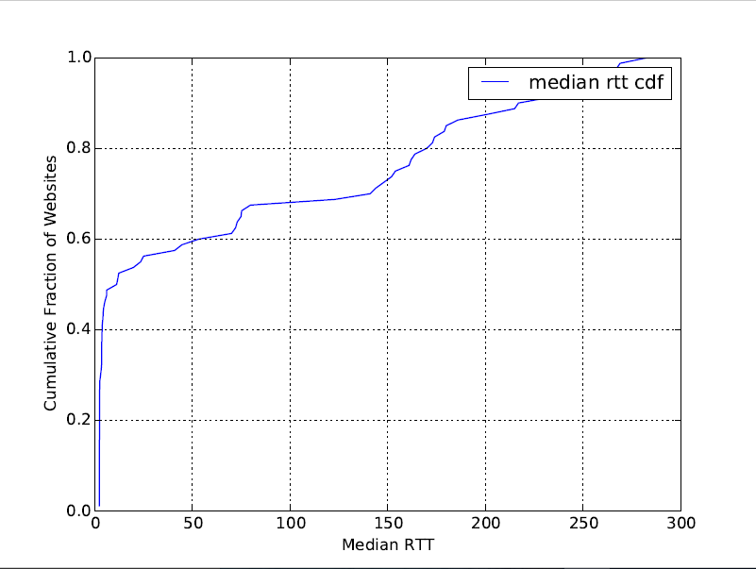

1. todayhumor.co.kr: {median rtt: 81.6, drop rate: 0.0, max rtt: 90.9}

google.com: {median rtt: 2.74, drop rate 0.0, max rtt: 34.9}

taobao.com: {median rtt: 301.0, drop rate: 0.17, max rtt: 311.0}

zanvarsity.ac.tz: {median rtt: 282.0, drop rate: 0.012, max rtt: 438.0}

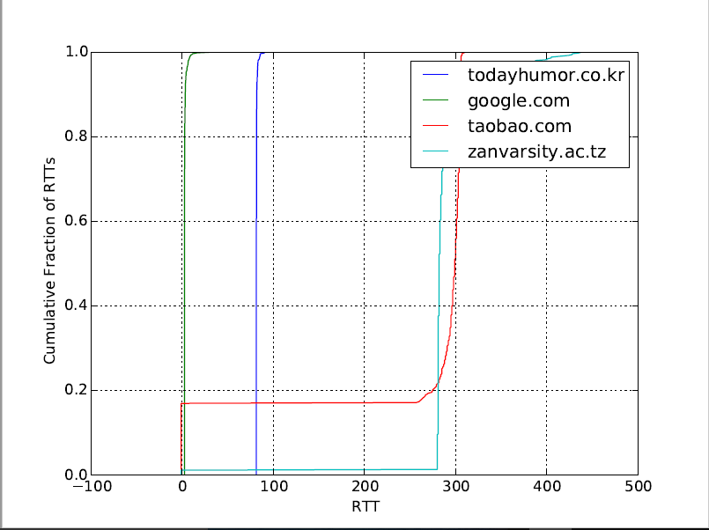

1. multiplier for google.com: 14.49

multiplier for zanvarsity.ac.tz: 5.278

Ping time is not equal to the speed of light time because routers will slow down transfer speeds by taking time to process the packet and deciding where it should go.

Also, another reason is that the speed of light gets slower when you go through wires (as compared through a vacuum)